Board of Trustees Meeting Minutes
February 17, 2021
5:30 p.m.

Present: Dina Condodemetraky, Alison Murphy, Bri Rys, Sarah Osborne, Eric Raymond, Mbula Ratzlaff, Colleen Sliva, Heather Warfield, and Beth McClure (not a board member)

- Call to Order: Meeting was called to order at 5:32 p.m.
- Secretary’s Report:
  - Vote on Meeting minutes from January 20, 2020: Motion to accept by Osborne, second by Raymond. Motion passed with seven ayes and one abstention.
- Treasurer’s Report and Manifest
  - Review and vote on January report and manifest: Motion to accept by Sliva, second by Rys. Motion passed unanimously with eight ayes.
- Principal’s Report
  - Building update: Loan has been underwritten, wrapping up with USDA loan guarantee. SFES has signed the contract with Milestone. Projected start date in April 2021, completion end of January 2022. Before construction starts, will need to move the gate to open into the lower field so students can access it to play in.
  - Charter renewal update: Tentative schedule from NH DOE. The team will want to meet with the board as part of the process. Intent to renew has been sent in.
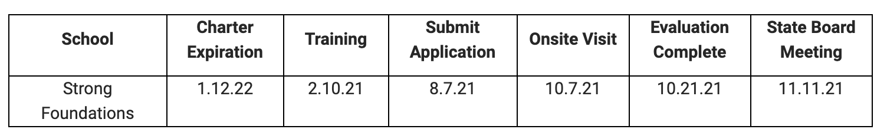
  - Audit: Due to the NH DOE by March 15. Have been in contact with the auditor to tell her we have a hard deadline, but do not have a delivery date at this time. Everything they need has been provided by us.
- Old Business
  - Budget Committee: McClure presented the draft of the budget. Plan to vote on the budget at the March meeting.
  - Task Force Update: Condodemetraky presented the update. The Task Force meets every 2 weeks to discuss any decisions related to COVID and has met twice since the last board meeting. There was discussion at the meetings about vaccine participation related to staff. Can’t mandate people to take it. Will keep track of who does. McClure will need to figure out how to deal with issues related to those who choose not to take it and then get sick. All families who have been remote and want to come back to hybrid were accommodated. If we reach capacity for social distancing, we will have to deny additional requests. Teacher vaccinations still expected to roll out in March. Our procedures are working. Not having any spike in infections, and to date there have been no cases transmitted in school. McClure showed the board the pie chart of the percentage of teachers who would get the vaccine. It was: Yes, 40; No, 17; Maybe, 5. Warfield asked what the current requirement is for teachers to get other vaccines. McClure answered that it is not required and we do not receive teacher health records as part of the background check.
- New business: None
- Public comment: Tammi Lemay asked about the plans for the construction project. McClure described the additional rooms that will be in the new addition, which are mainly common rooms. That will open up existing offices to be used for tutoring, testing, and for staff who currently share professional space. It will also open up the Art/Music room to be used as a classroom.
- Other business: Osborne asked if there are going to be changes to the Specials schedule (a rotation for the cohorts). McClure answered that it would happen on March 8.
- Meeting adjourned at 6:11 pm.

Date of next meetings: March 17, 2021 and April 21, 2021 at 5:30 p.m. at 715 Riverwood Drive, Pembroke, NH or through remote means as determined by the Board of Trustees
***
Trustee | Term
Dina Condodemetraky (Chair) | 3 Year Term – Sep 2019 to Aug 2022
Colleen Sliva | 3 Year Term – Sep 2020 to Aug 2023
Bri Rys | 3 Year Term – Sep 2019 to Aug 2022
Eric Raymond | 2 year term - Sep 2020 to Aug 2022
Heather Warfield | 3 year term – Sep 2018 to Aug 2021
Open | 3 year term - Sep 2020 to Aug 2023
Mbula Ratzlaff (parent term) | 1 Year Term – Sep 2020 to Aug 2021
Alison Murphy (parent term) | 1 Year Term – Sep 2020 to Aug 2021
Sarah Osborne (parent term) | 1 Year Term – Sep 2020 to Aug 2021

