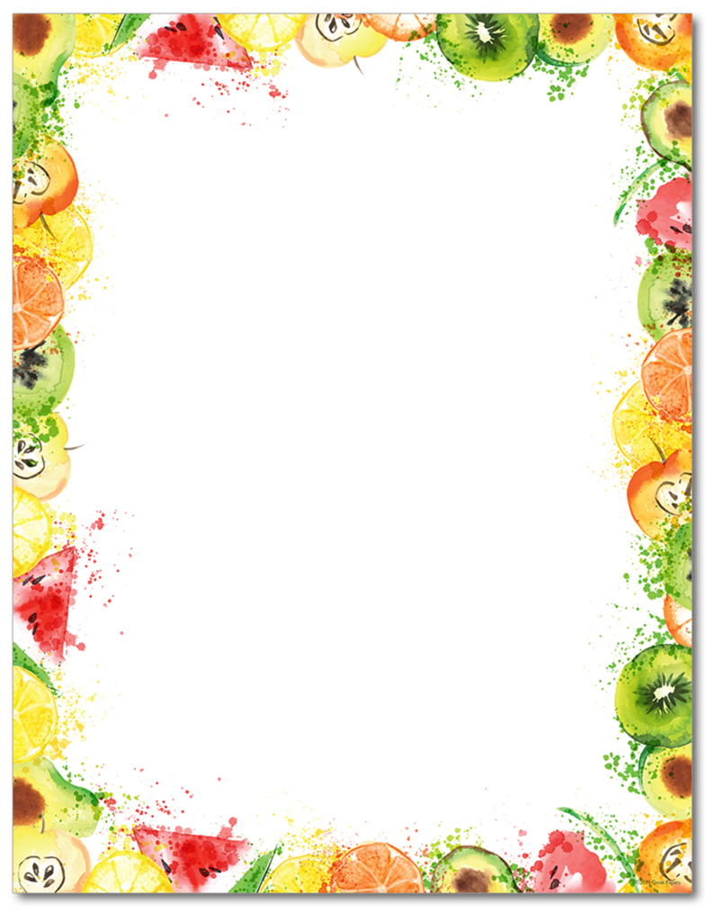
Strong Foundations
Lunch Menu
February 2021
Monday | Tuesday | Wednesday | Thursday | Friday
1  Pizza Max Sticks with Sauce  Or  Yogurt Boat | 2  Pizza Max Sticks with Sauce  Or  Yogurt Boat | 3  Turkey & Gravy  Mash & Veg  Or  Yogurt Boat | 4  Turkey & Gravy  Mash & Veg  Or  Yogurt Boat | 5
8  French Toast  With Sausage  Or  Yogurt Boat | 9  French Toast  With Sausage  Or  Yogurt Boat | 10  Chicken Nuggets  And Noodles  Or  Yogurt Boat | 11  Chicken Nuggets  And Noodles  Or  Yogurt Boat | 12
15  Pulled Pork  & Cheese Nachos  Or  Yogurt Boat | 16  Pulled Pork  & Cheese Nachos  Or  Yogurt Boat | 17  Cheese Pizza  Slice with Fries  Or  Yogurt Boat | 18  Cheese Pizza  Slice with Fries  Or  Yogurt Boat | 19
22  Vacation  No School | 23 | 24 | 25 | 26
 | Reminder to order remote meals for pick up after school |  | Milk Choices:  1% White or Fat Free Chocolate
Menu Subject to change without notice. This Institution is an Equal Opportunity Provider.

