Strong Foundations Summer Camp 2018

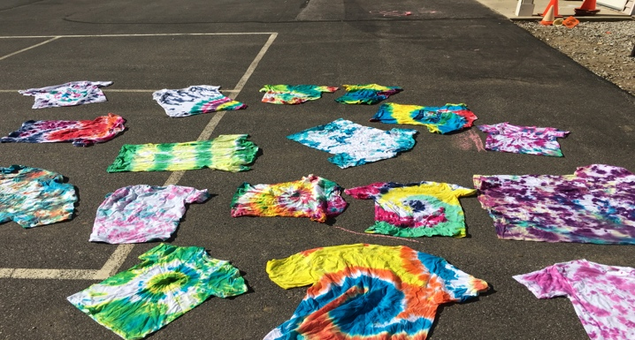

July 2nd- July 27th
9:00am-3:00pm
Before care available
$160.00/per week/per child

Theme: “Z to A…
and every letter along the way…”
*Calendar coming soon!*

Questions? Please e-mail: Jillian Harbour at jharbour@sfnh.org or Tish Murphy at tmurphy@sfnh.org

